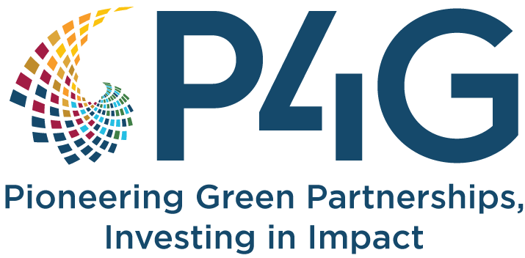

Guidance for P4G Knowledge Products
Knowledge products are key to sharing and understanding the impact data shared by partnerships in compliance with their Monitoring, Evaluation and Learning frameworks. They give a story to the figures and data submitted by partnerships in ways that are understandable and actionable by stakeholders.
P4G requires all partnerships to develop two knowledge products during their funding period.
- A product on the policy and regulatory engagement the partnership undertakes to strengthen the enabling market environment in which it operates.
- A product on the success of the business model and learnings from the startup’s journey to investment readiness.
Below are the types of knowledge products a partnership can produce within these two categories and guiding questions to address in these reports.
- Knowledge Product on Strengthening Enabling Systems (Max 5 pages)
Understanding the enabling market ecosystem within which the partnership is operating and learning how to navigate the potential challenges towards becoming investment ready is key to a partnership’s success. This is especially important because policy and regulation are some of the key drivers towards success of any business proposition.
Enabling systems work- Besides engagement with the National Platforms on policy and regulation, partnerships are expected to develop information pieces around the work that the partnership is doing to influence or shape the enabling environment within which they are operating in the context of becoming investment ready. This includes interventions around advocacy, policy and regulatory work detailed by individual partners in their workplan and budget. These could take the form of:
- Reports: Comprehensive documents that provide detailed analysis and findings on policy and regulatory issues.
- Technical Papers: In-depth discussions on specific technical aspects of a policy or regulation.
- Guidance Materials: Practical resources that offer step-by-step instructions or frameworks for implementing policies.
- Policy Briefs: Concise documents that summarize key issues, implications and recommendations for policymakers.
- White paper: authoritative document used by stakeholders to present detailed policy proposals or positions on specific issues.
- Working papers: Research, analysis or thinking that is still under development that are designed to be a mechanism for sharing preliminary findings with target audiences. This knowledge product should be tailored and reflect the activities under the enabling environment pillar as designed in the approved workplan.
Partnerships are expected to produce a minimum of one piece from the above choices.

- Case Study on the Business Model (Max 10 pages)

P4G expects a case study that details the pathway the startup has navigated towards becoming investment ready. This knowledge product is aimed at qualitatively validating the impact of the proposed business model by the partnership and should be tailored to an external audience of relevant stakeholders within the sector or sub-sector. Key considerations when developing this case study include.
- Background and problem analysis: Define the problem being addressed by the business in terms of magnitude, severity and prioritization in global and or regional agenda (should be evidence based and include data & facts with citations).
- Solution: Clear definition of the product that the business has developed as a solution to the problem above, including why the product is innovative and its additionality to the country/ sub-sector and/ or current state of things.
- Defined methodology: Description of the approach, methods, tools and innovations used to execute the startup or business.
- Business model: Explanation of how the product has been packaged for the market, who the customers are, how it reaches these customers, and how it generates revenue for the business.
- Results: Summary of the outcomes achieved, including quantitative and qualitative results based on the P4G MEL framework. For partnerships that received investment or investor commitments, please share the key levers that helped leverage this commitment and non-confidential information about the investors, investment amounts and types of investment (e.g. equity, debt, concessional, etc.). Include customer experience, interview/ quotes, and any external feedback Impact.
- Challenges and solutions: Impediments (and solutions) to investment and scale readiness; highlighting the challenges faced by the business in fully scaling the product in the market and being ready for external (follow-on) investment. These could be internal to the business or from the external environment. These can also be related to the enabling market environment in which the business operates and a brief overview of the startup’s contributions to improve the policy and regulatory framework.
- Lessons learnt: Key takeaways that can inform investment readiness and scaling of similar businesses.
- Recommendations: Suggestions for improvement or future actions based on partnership experience that can influence or help others in the sector.
- Annex 1: Data comparison on ESG and Financial Data
Please include a section that compares historical data with current data for key ESG and financial metrics. This comparison could be detailed using the tables provided below:
Financial Metrics | Before | After | Notes
Revenue | $X | $Y | Total revenue
Gross Profit | $X | $Y | Revenue minus cost of goods sold (COGS)
EBITDA | $X | $Y | Earnings before interest, taxes, depreciation, and amortization
Net Income | $X | $Y | Profit after all expenses and taxes
Operating Expenses | $X | $Y | Total expenses for operations
Cash Flow | $X | $Y | Net amount of cash inflow/outflow
Number of Consumers | X | Y | Number of clients
Number of Offtake Agreements | X | Y | Number of purchase agreements signed
Client Growth Ratio YoY | X | Y | Increase of clients in the last year
Gross Margin Ratio | X% | Y% | Gross Profit / Revenue x 100
Gross Ebitda Ratio | X% | Y% | Ebitda / Gross Profit x 100
Debt-to-Equity Ratio | X | Y | Describe financial leverage in the last FY
Customer Acquisition Cost (CAC) | $X | $Y | Cost of acquiring a new customer
Lifetime Value (LTV) | $X | $Y | Total revenue expected from a customer
Investment Achieved | $X | $Y | Investment achieved through equity, debt and mixed instruments

ESG Metrics |  | Before P4G Funding |  | After P4G Funding |  | Notes
Carbon Emissions (tonnes CO2e) | X tonnes |  | Y tonnes |  | Total CO2 emissions in the last FY
People positively affected | Number |  | Number |  | These are individuals directly and indirectly positively affected by climate resilience or adaptation related to the climate business commercial partner product or solution.
Jobs created | Number |  | Number |  | Jobs created outside of the commercial partner
Gender Diversity (% female employees) | X% |  | Y% |  | Percentage of female employees
Compliance and Risk Management | Describe |  | Describe |  | Compliance Report (Laws and Regulations)  Risk practices (processes and responsabilities)  Risk management documentation (identification, mitigation an control)  Audit policies (internal - external)
ESG Reporting and Transparency | Describe |  | Describe |  | Frequency of ESG reporting (# reports per year),  Adherance to Standards (GRI, SASB, TCFD)  Clear governance structure  Integration with financial reporting
Board Diversity | X% |  | Y% |  | %of Women of the board members

Please include quotes from beneficiaries, pictures, data, video links and infographics as relevant.

Updated March 2025

